RTTS Train Tracking System

User Manual

Contents

How Can I register to the System? 2

How Can I Log in to the System? 3

How Can I Reset My Password If I Forgot the Password? 4

How can I search for the Train? 6

How can I view Train Timetable? 8

How can I add Train News? 9

How can I Add System Feedback? 11

How can I View Tourism Places? 13

How can I Get user features? 16

# How Can I register to the System?

**Visit www.RTTS.co >> click on the Register button.**

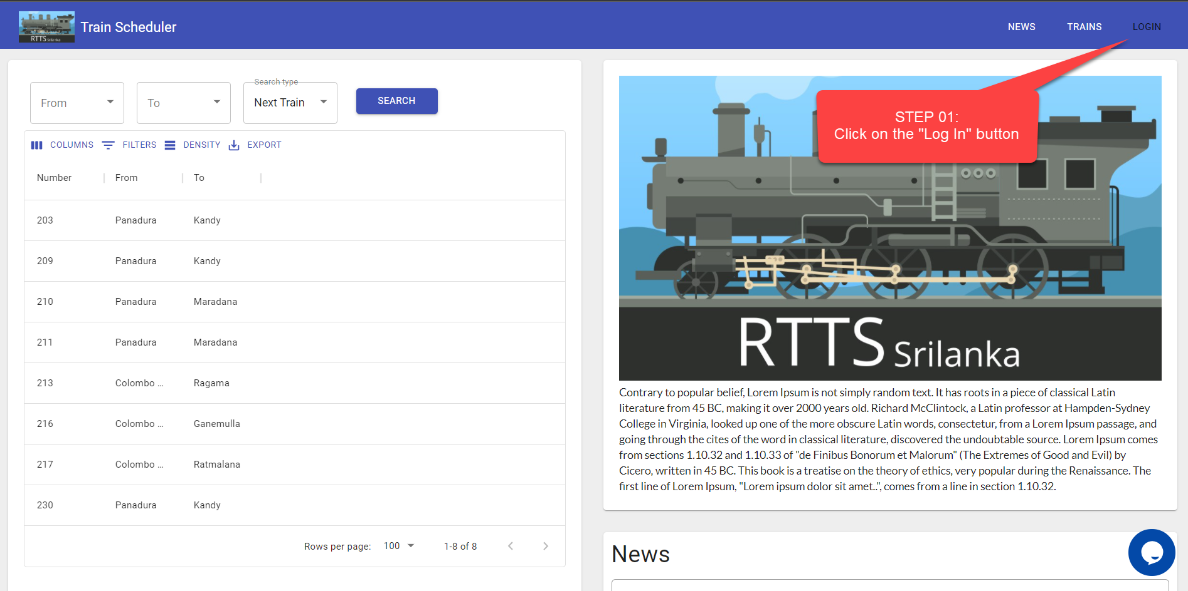

**Fill all the required details in the student registration form.**

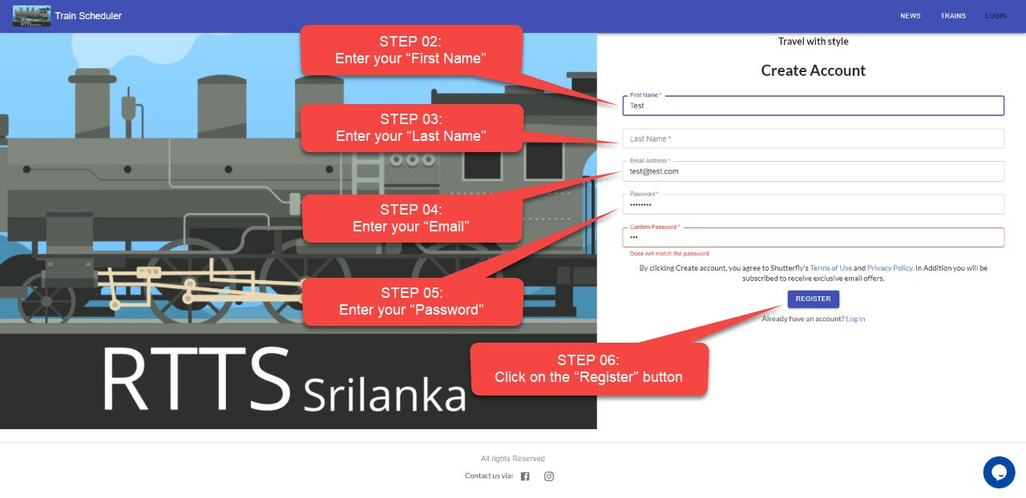

# How Can I Log in to the System?

**Visit www.RTTS.co >> Click on the Log in button**

**Enter your email & password to Sign-In to your Account.**

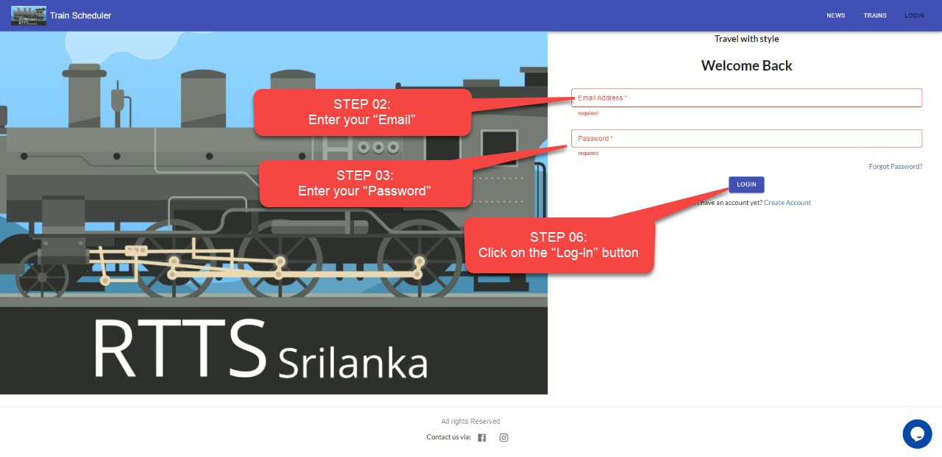

# How Can I Reset My Password If I Forgot the Password?

**Visit www.RTTS.co >> Click on the Log In button.**

**Click on the “Forgot Password” to reset your password**

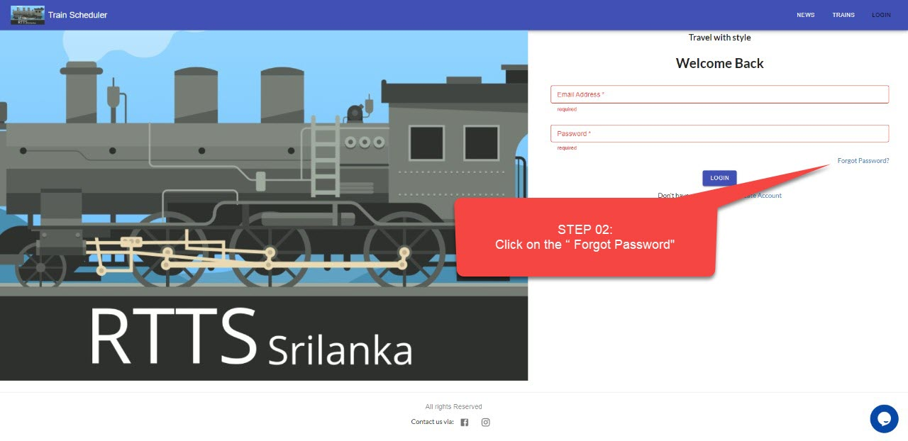

**Enter your account email address & Click on the “Send Email” button**

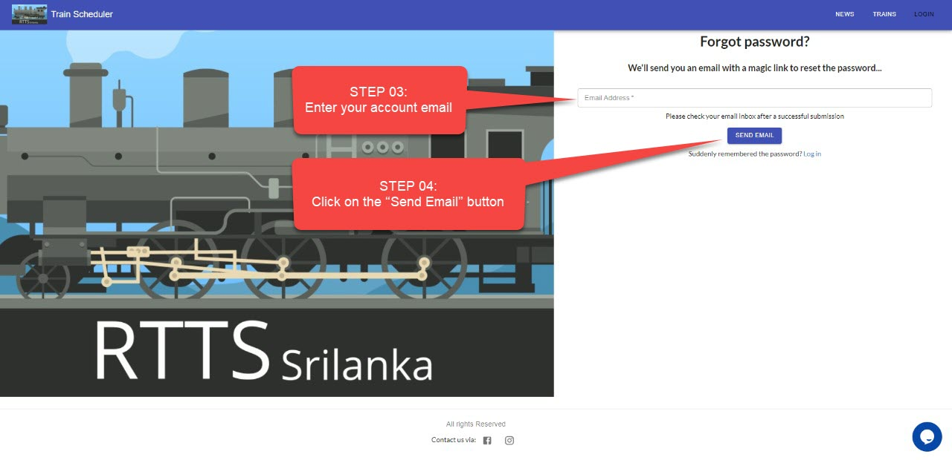

**Now check your email inbox to get a reset password link**

**Open the “Password Reset Request” email**

**Click on the link to reset your password**

**After successful reset your Password you will redirect to your Account Dashboard**

# How can I search for the Train?

**Visit www.RTTS.co >> Click on the From Dropdown button.**

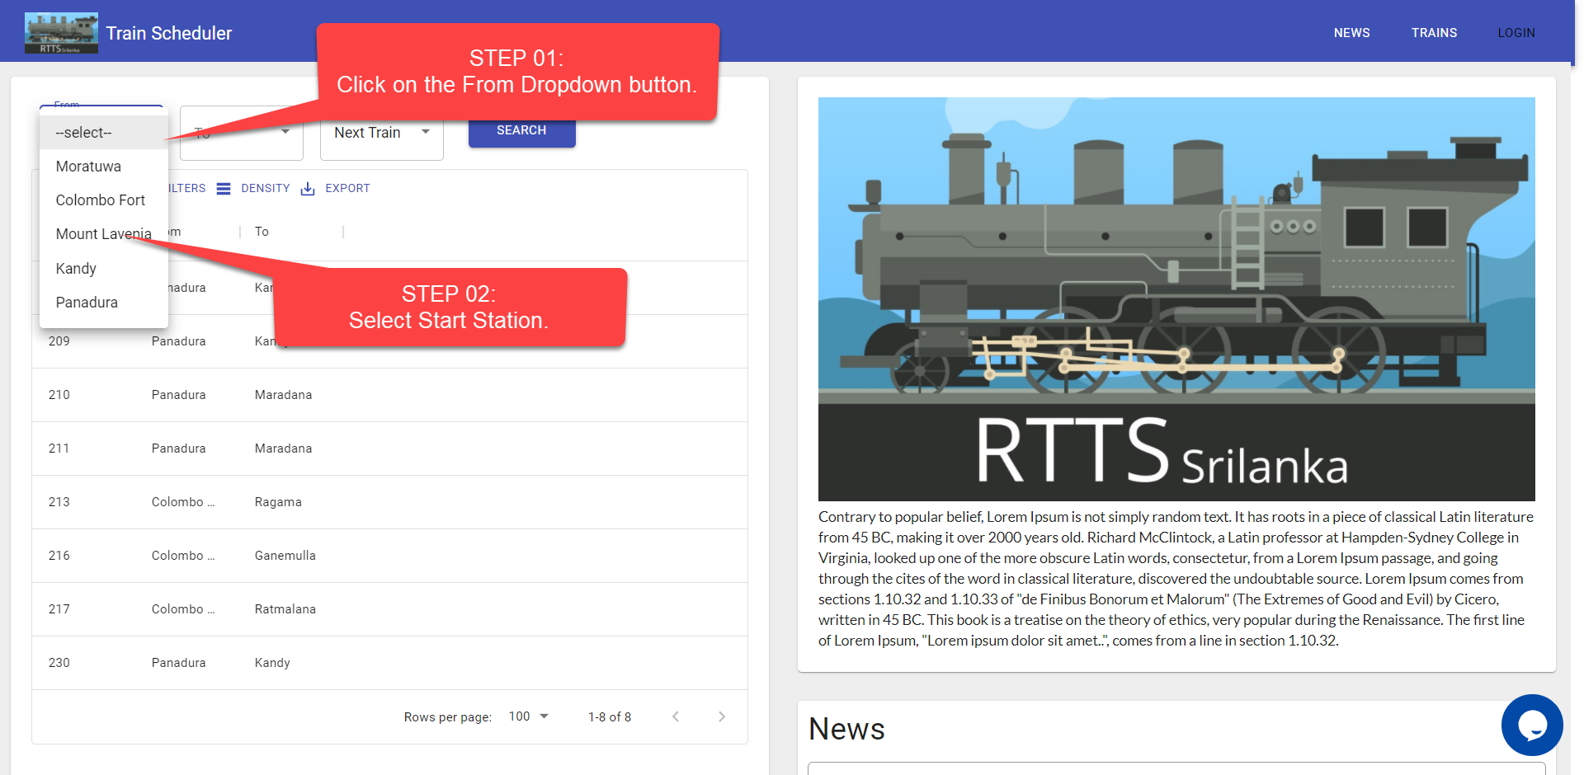

**Click on the To Dropdown button.**

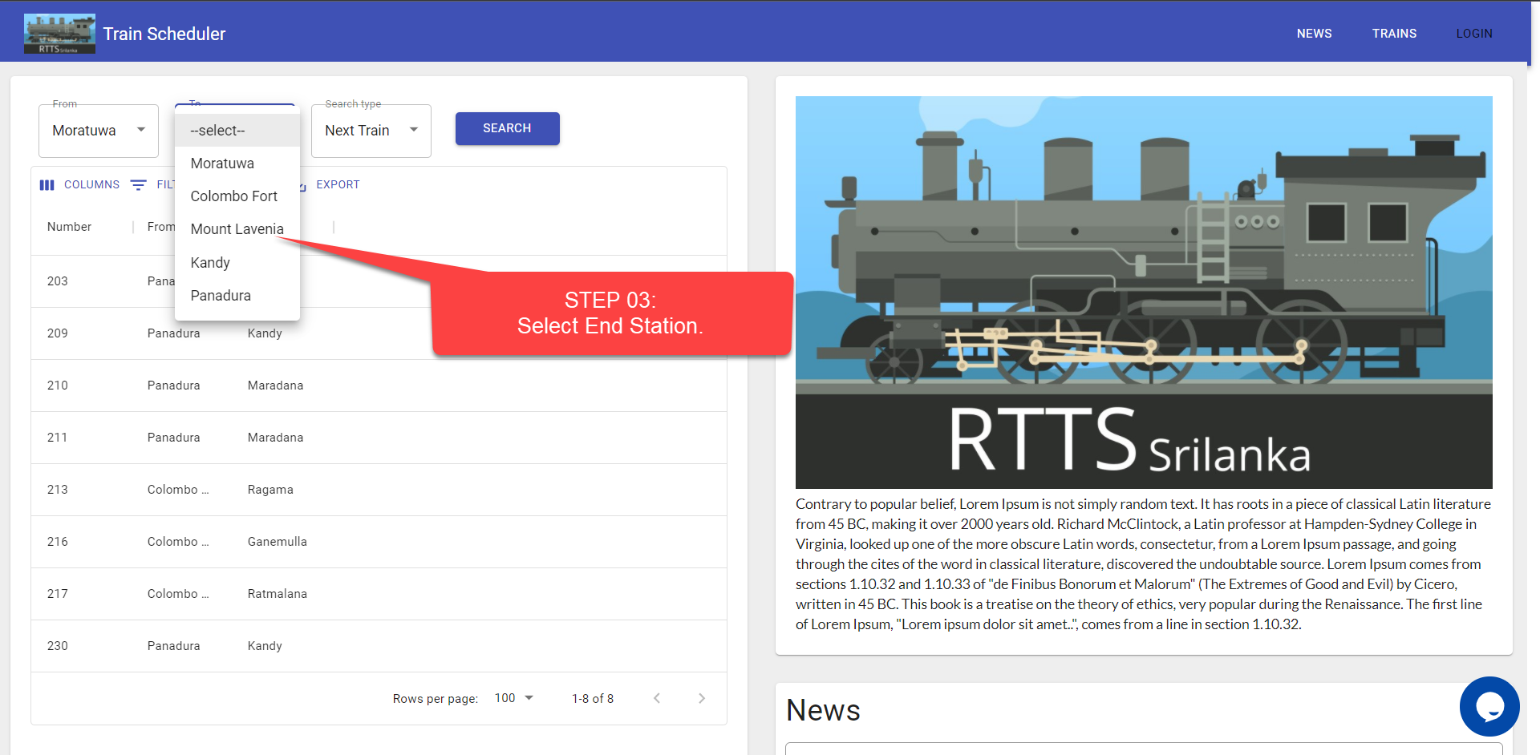

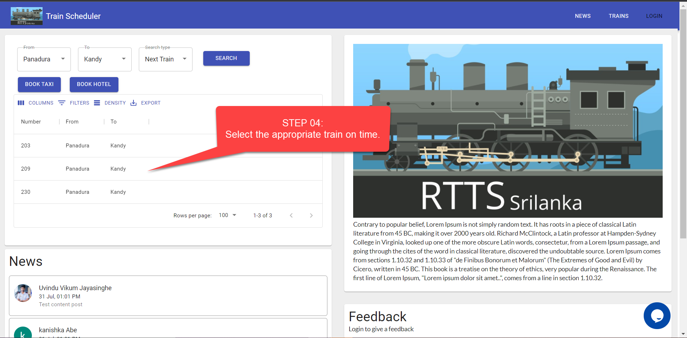

**Indicates the train route and the time it will take for the train to arrive.**

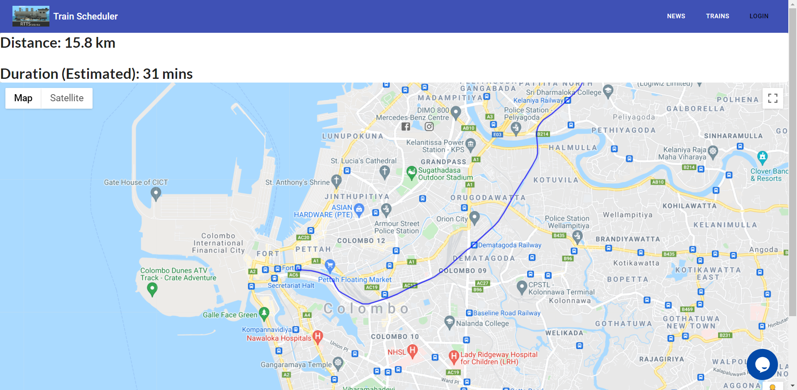

# How can I view Train Timetable?

**Visit www.RTTS.co >> Click on the Search Type Dropdown button.**

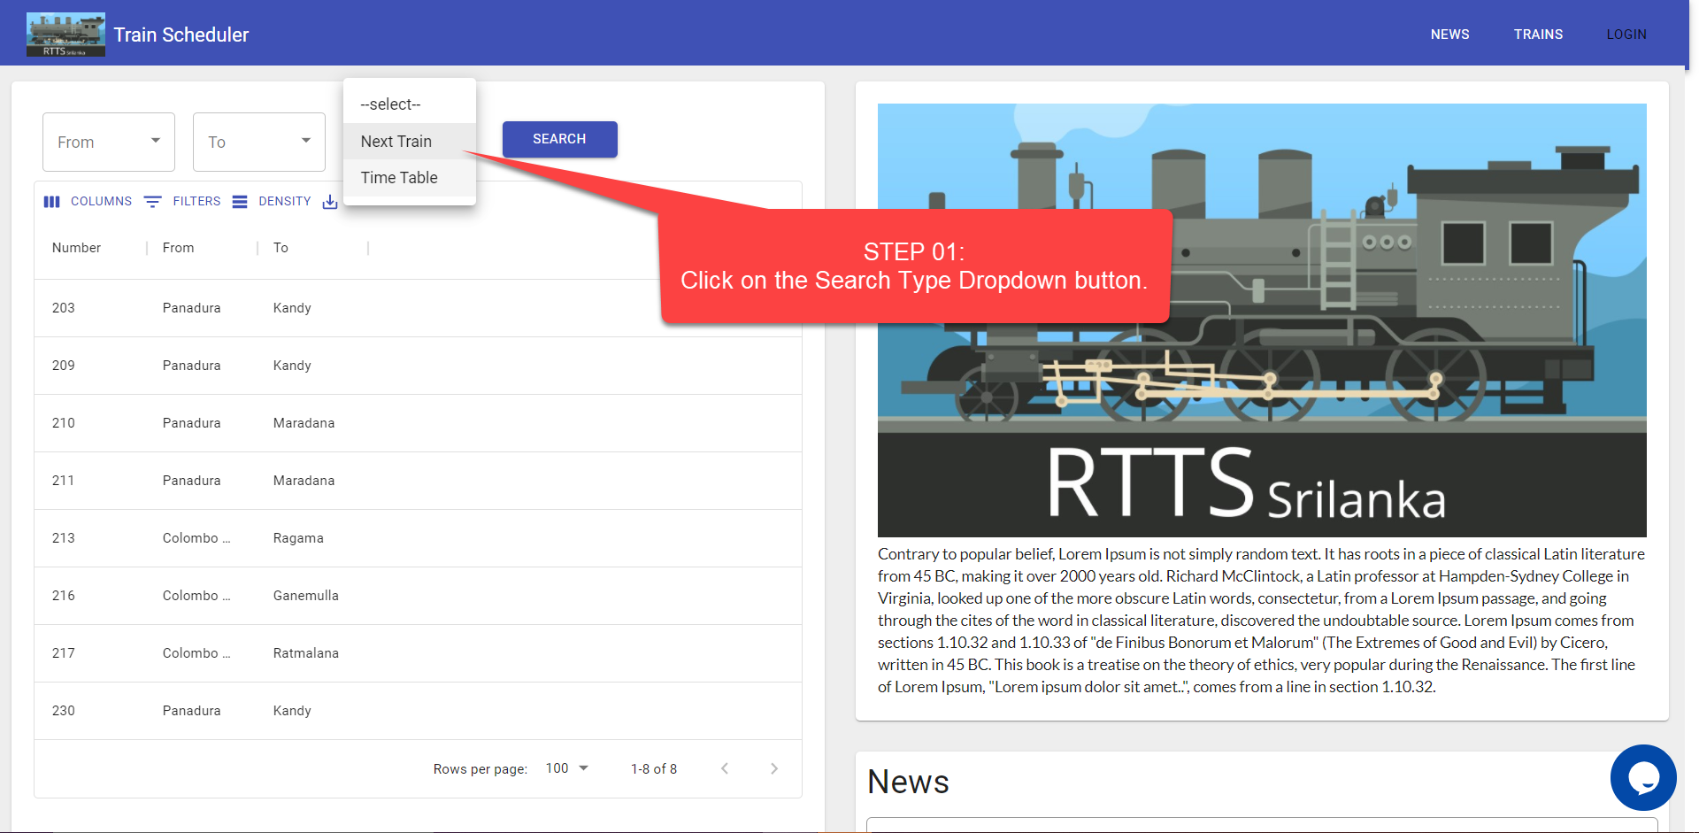

**Check the Train with Time or Train Number.**

# How can I add Train News?

**Visit www.RTTS.co >> Click on the Log In button.**

**Enter your email & password to Sign-In into your Account.**

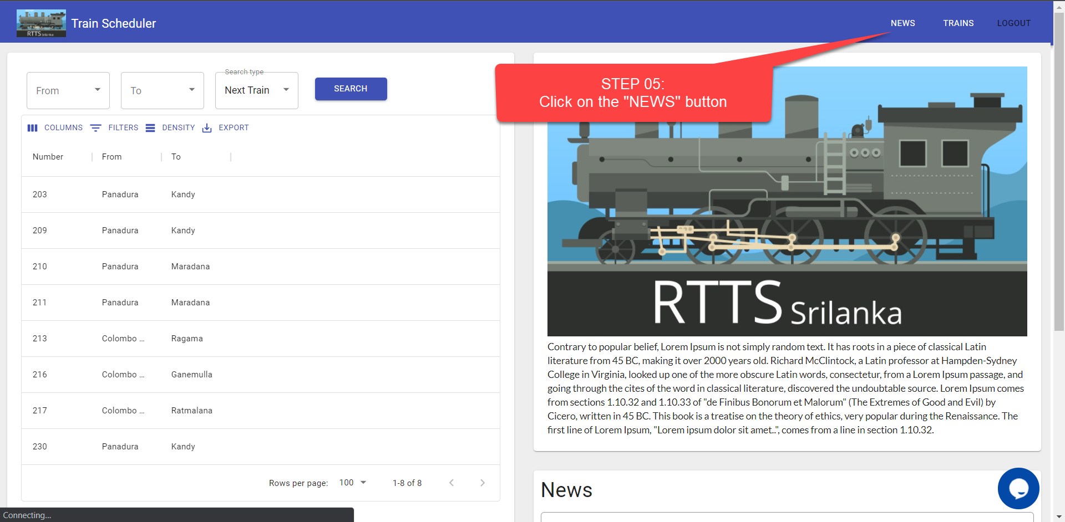

**Add your NEWS and Click on the "Add" button.**

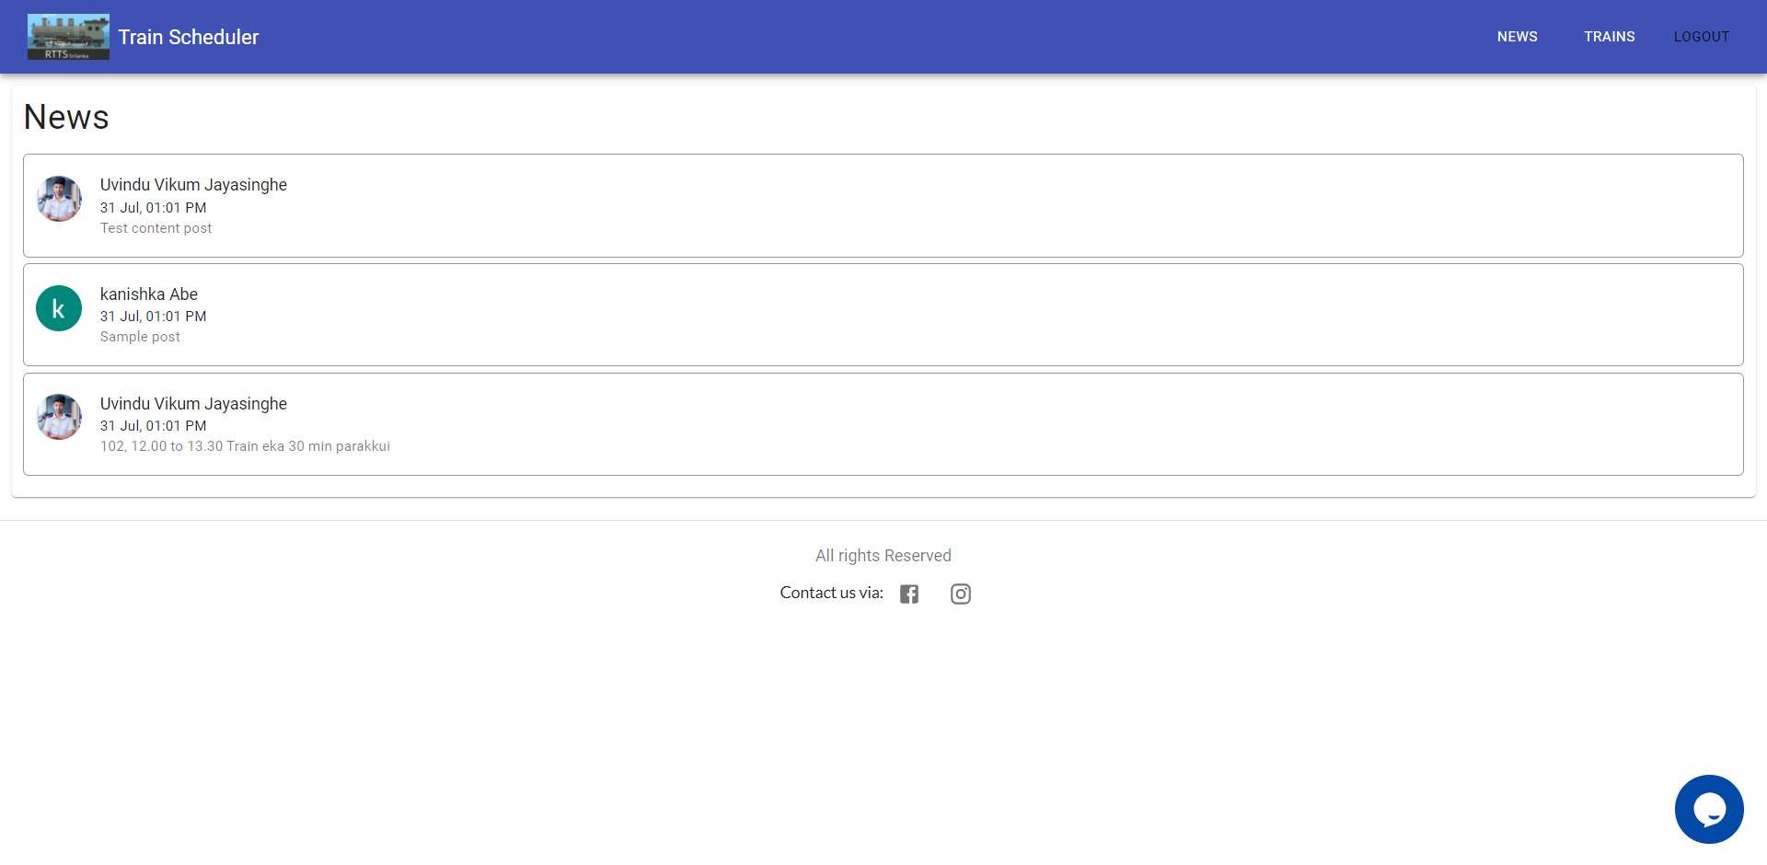

# How can I Add System Feedback?

**Visit www.RTTS.co >> Click on the Log In button.**

**Enter your email & password to Sign-In into your Account.**

**Add your Feedback and Click on the "ADD FEEDBACK" button**

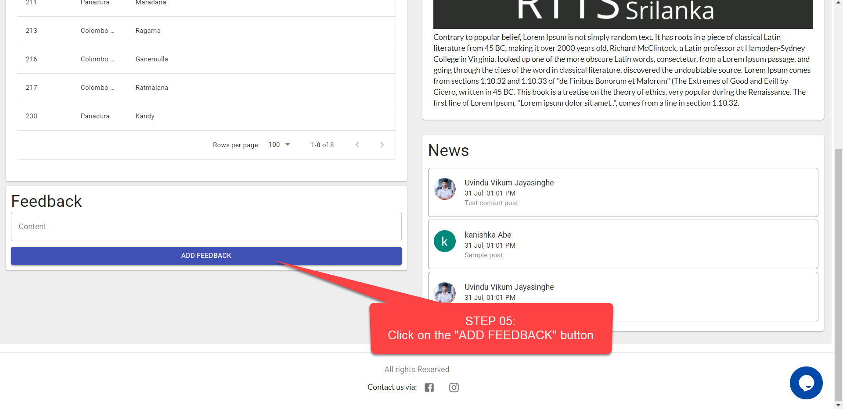

# How can I View Tourism Places?

**Visit www.RTTS.co >> Click on the Log In button.**

**Enter your email & password to Sign-In into your Account.**

**Click on the From Dropdown button.**

**Select your Tourism Place.**

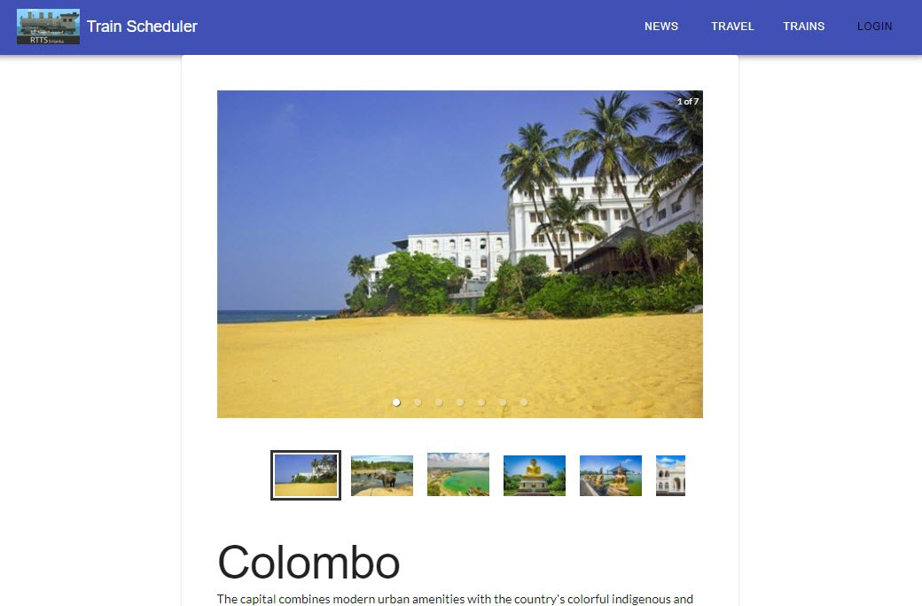

# How can I Get user features?

**Visit www.RTTS.co >> Click on the From Dropdown button.**

**Click on the To Dropdown button.**

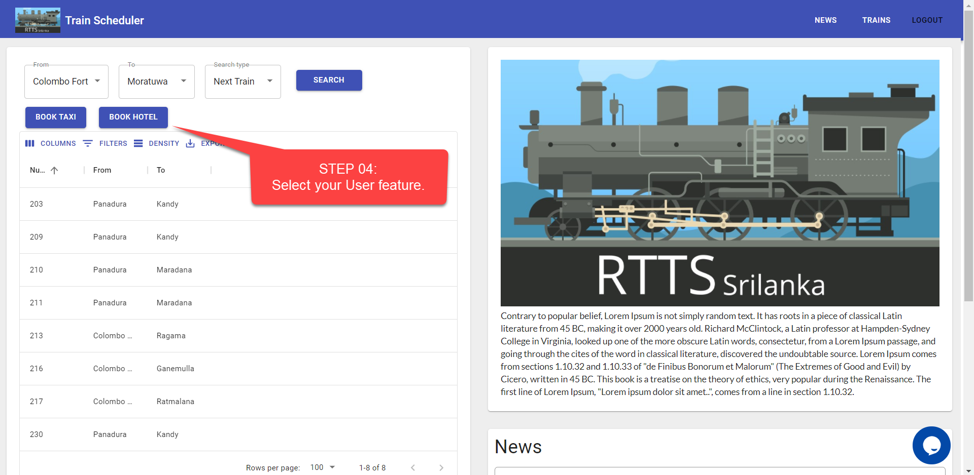

**Select your user feature.**

**End.**